

v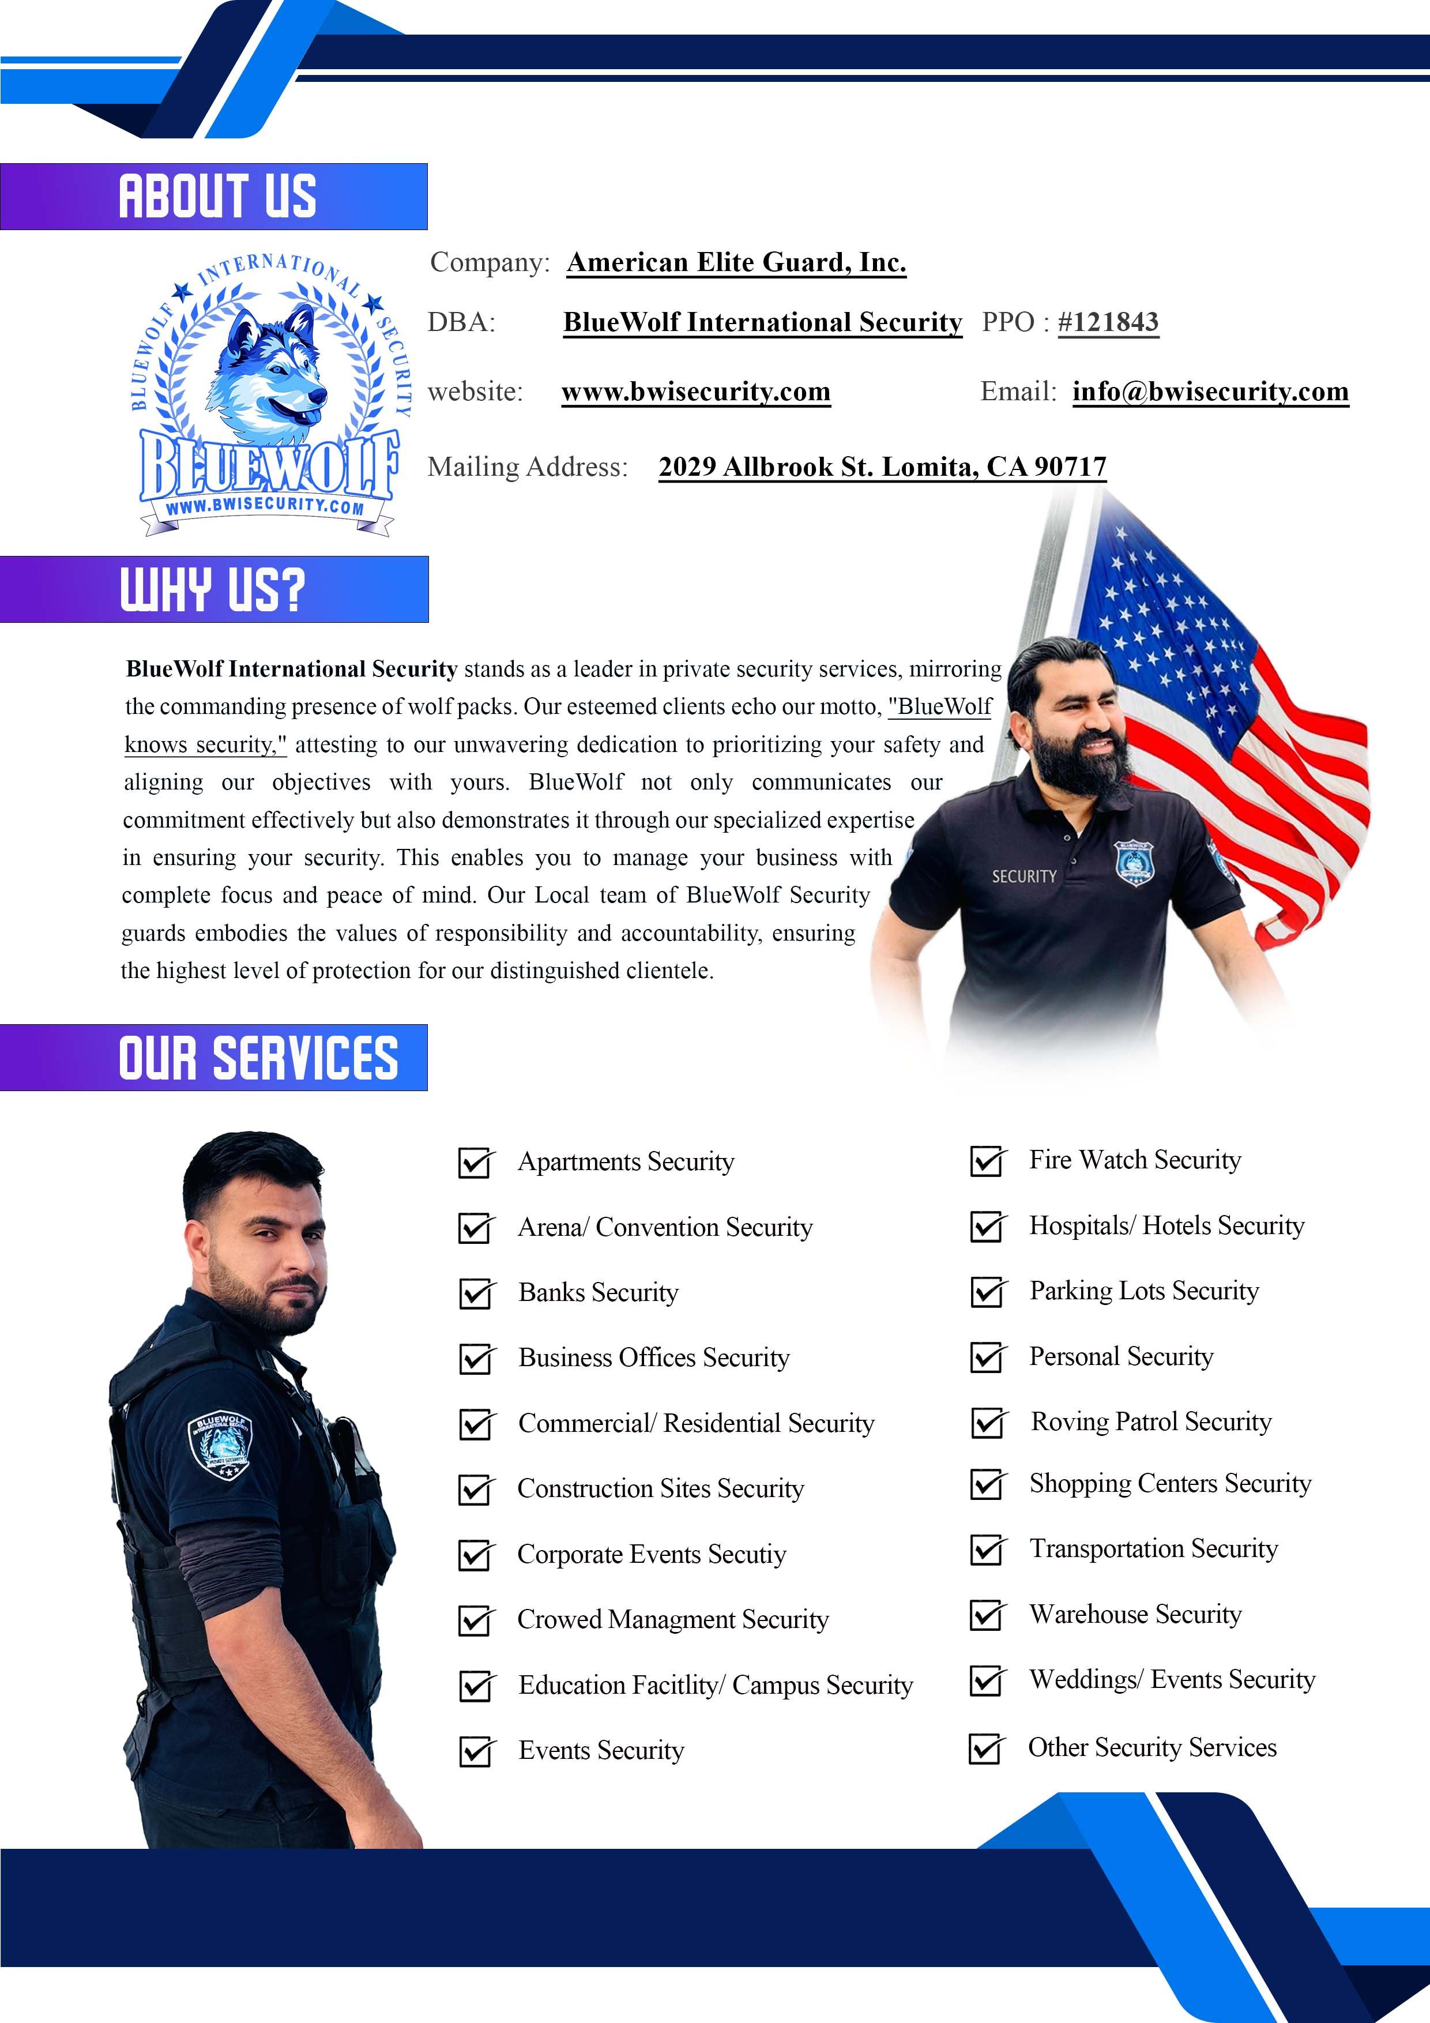

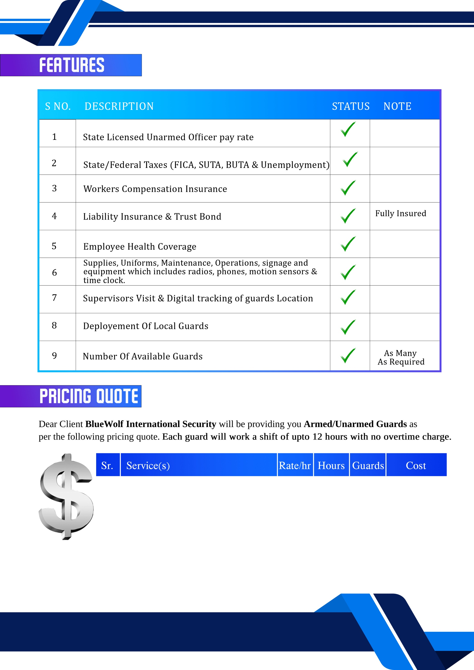

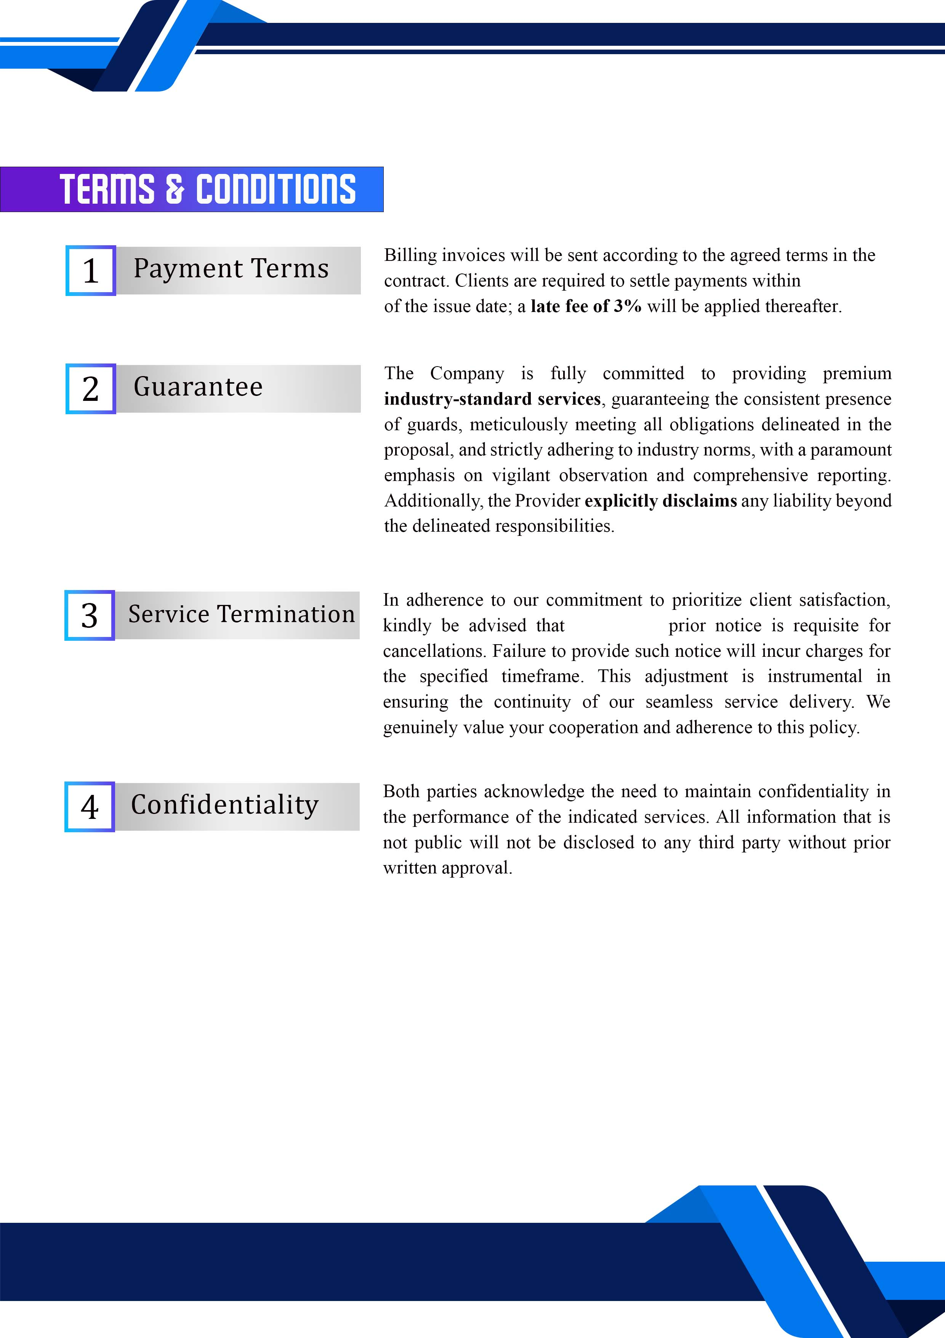



**1. Introduction**  
We appreciate the opportunity to propose our dedicated security guard services for your facility. Recognizing the critical importance of uninterrupted operations, we understand the need for reliable, round-the-clock protection to safeguard assets, personnel, and infrastructure. Our company emphasizes professionalism, vigilance, and non-escalatory security practices, while leveraging advanced technology to provide comprehensive 24/7 coverage.

**2. Guards & Expertise**  
Our experienced security personnel are trained to monitor, patrol, and protect industrial, commercial, and storage environments. Their core areas of expertise include:

* Access control and perimeter security to prevent unauthorized entry.
* Continuous monitoring and patrols tailored to facility layouts.
* Emergency response and incident management to ensure immediate action when needed.
* Conflict resolution and de-escalation to manage situations effectively without disrupting operations.

With proven experience across diverse industries and regions, we provide services that maximize protection while delivering peace of mind to our clients.

**3. Technology Integration**  
Our security approach integrates human expertise with advanced technology to enhance efficiency and accountability. Systems include:

* 24/7 surveillance with real-time reporting.
* Guard tracking systems ensuring transparency and constant presence.
* Smart communication tools enabling rapid coordination and response.

This human-technology combination ensures proactive measures and swift responses to any potential risks.

**4. Conclusion**  
In conclusion, we are confident that our 24/7 security solutions, supported by trained professionals and innovative technology, will exceed expectations for safety and protection. We are committed to delivering reliable, customized security programs designed to safeguard your facility at all times.

Thank you for considering our proposal. We look forward to the opportunity to provide uninterrupted, dependable security services for your operations.

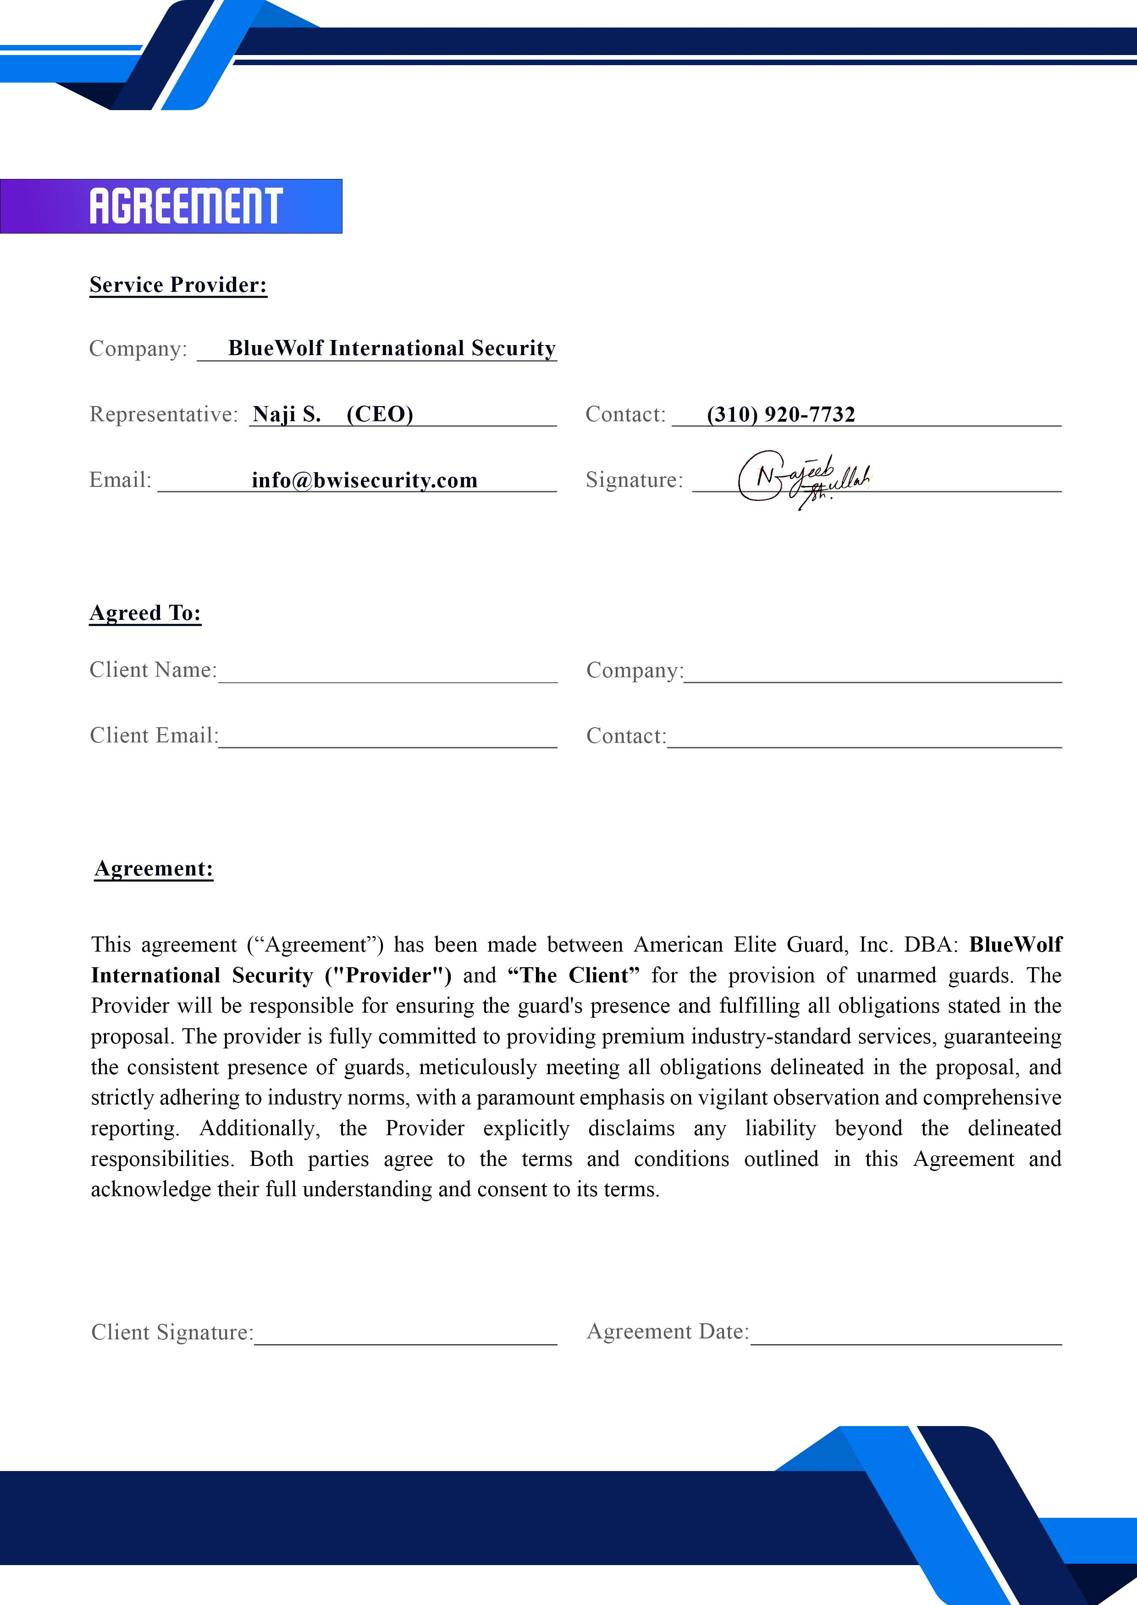

**Service Starting:**